**JMeter Example_3**

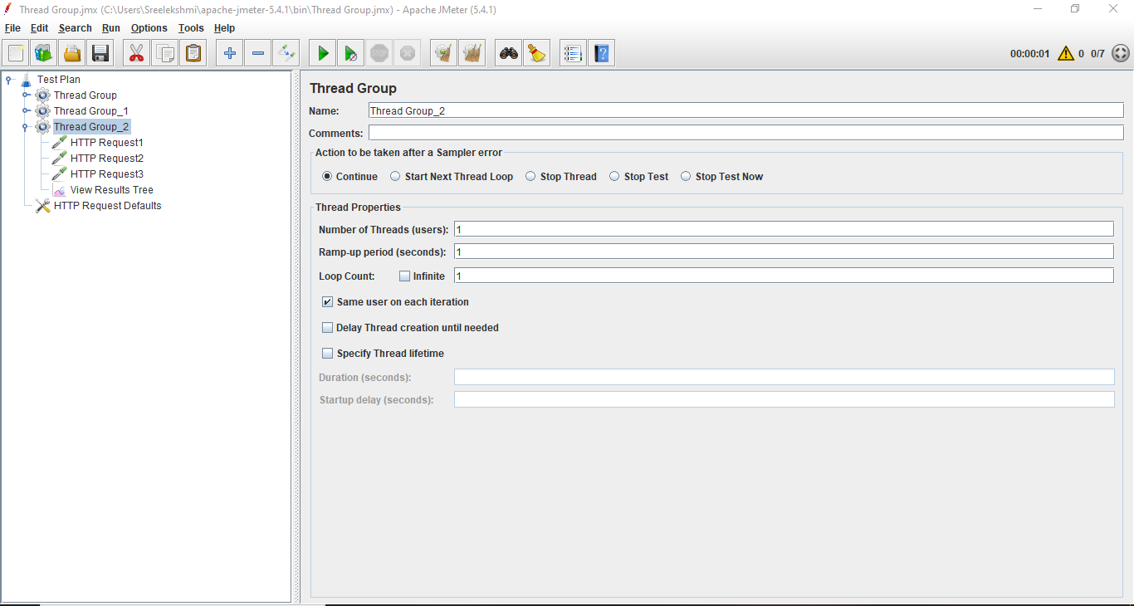After adding Thread group

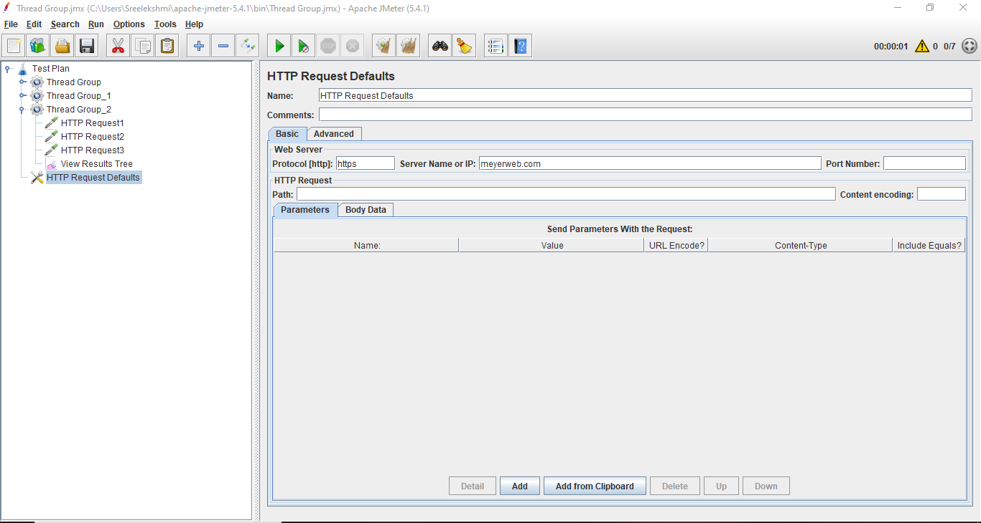After adding HTTP Request Defaults

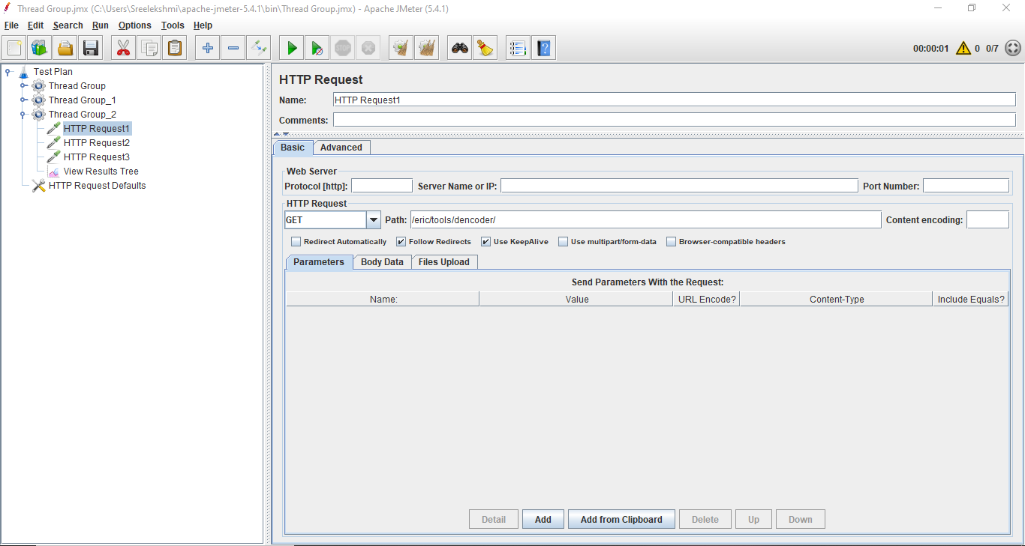After adding First Sampler HTTP Request 1

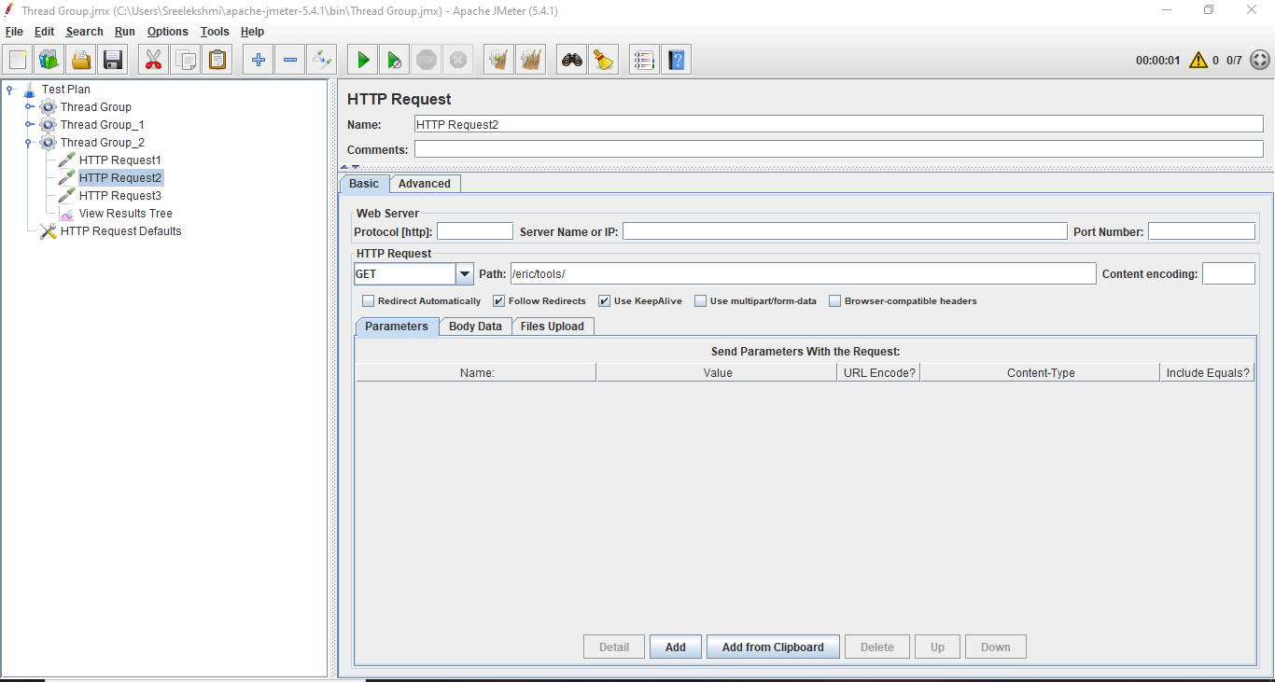After adding Second Sampler HTTP Request 2

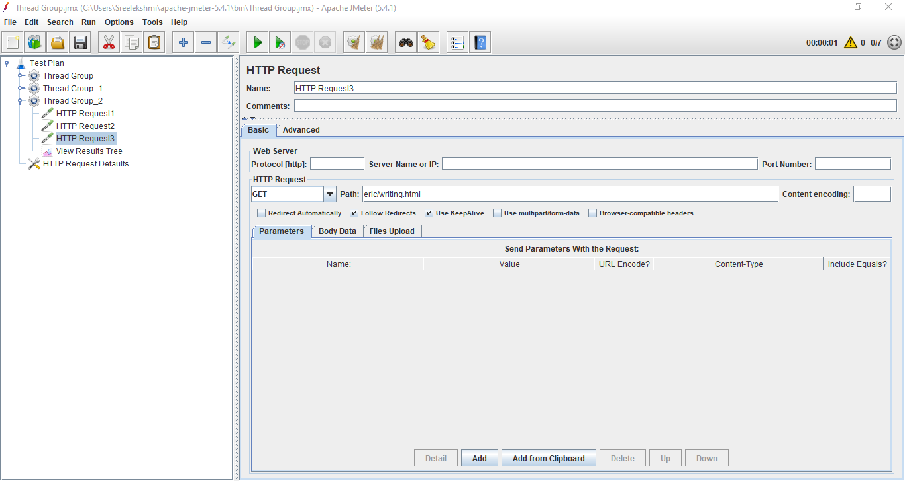After adding Third Sampler HTTP Request 3

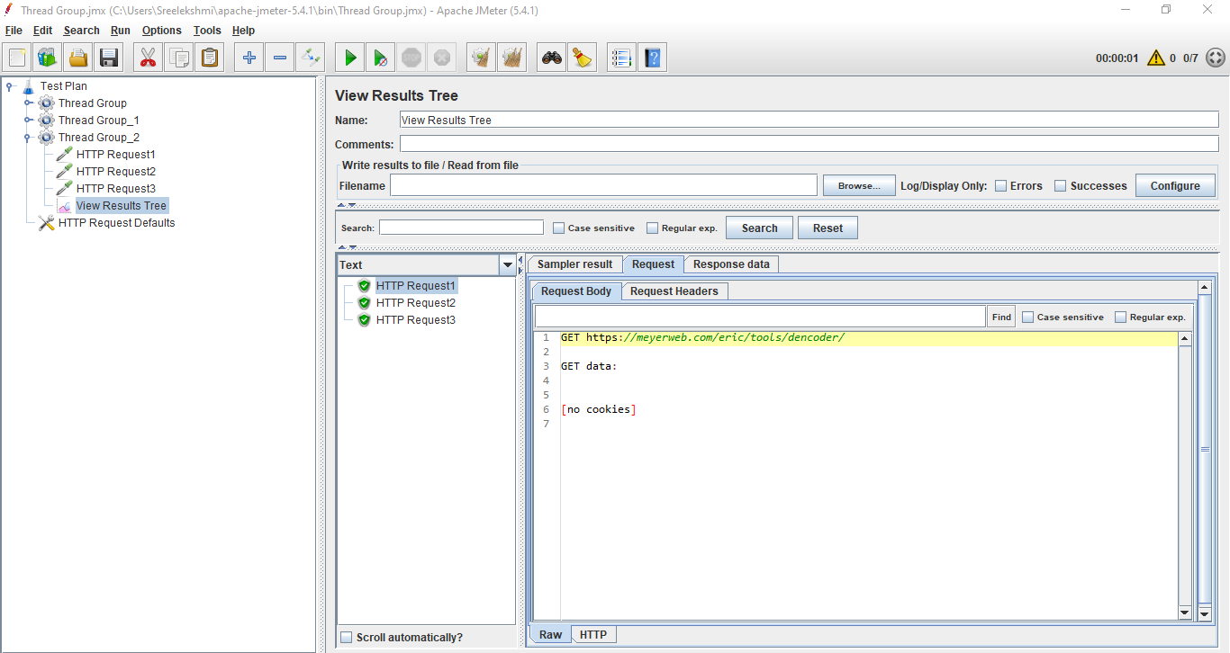Result of HTTP Request 1

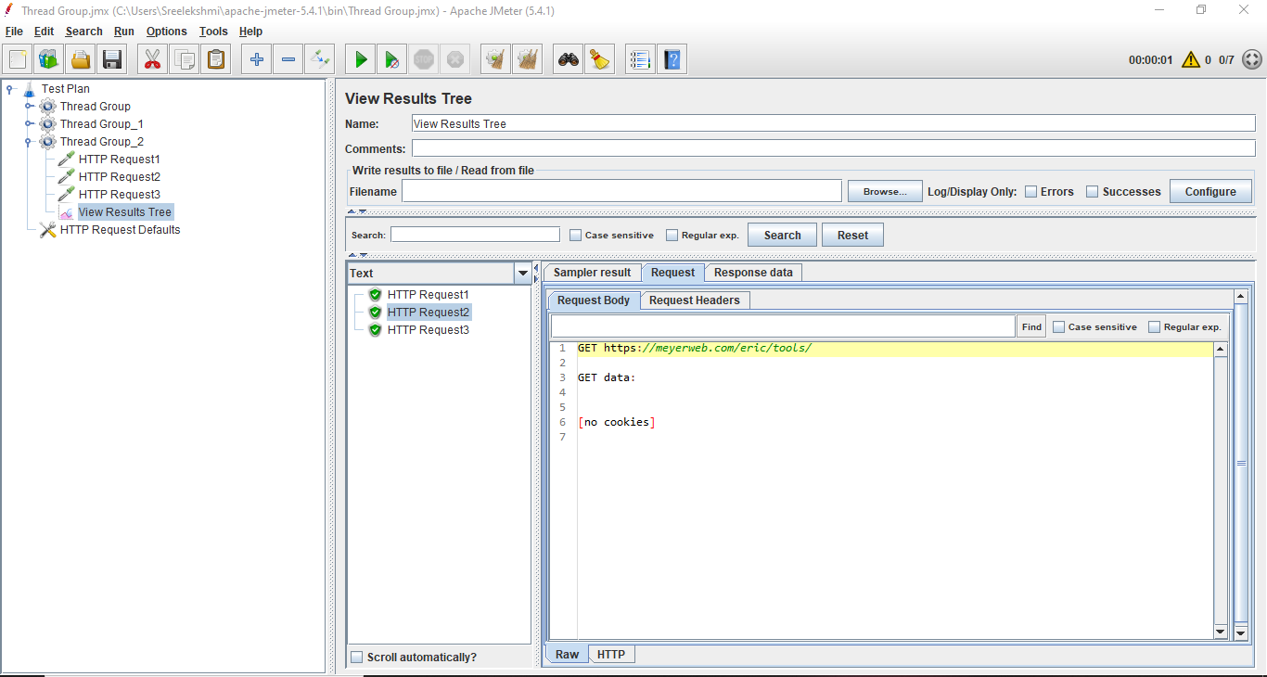Result of HTTP Request 2

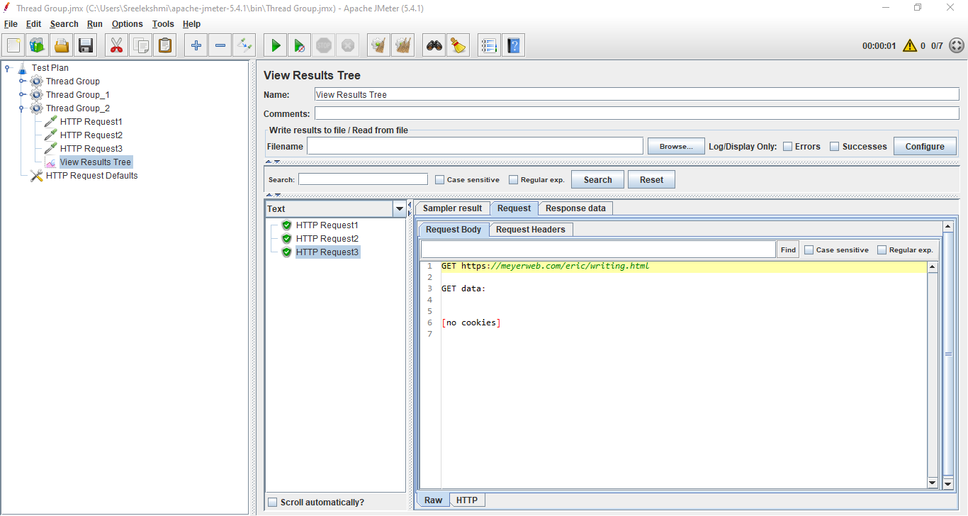Result of HTTP Request 3